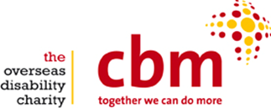

Event Volunteer, CBM UK

CBM is an international disability and development organisation, transforming the lives of people with disabilities in the world’s poorest communities.

We are seeking a volunteer to assist with the preparation and delivery of our exciting fundraising events programme, with a particular focus on an upcoming art exhibition on mental health. If you have a passion for event organisation, and an interest in supporting CBM UK’s work - we would like to hear from you.

Essential
- Good written communication skills
- Excellent telephone manner
- Ability to work on own initiative
- Friendly manner, able to build strong relationships

Desirable
- Creativity and practical approach to exhibition design
- Experience within a charitable organisation
- Knowledge of disability issues

Availability
- Ideally able to commit to 0.5 – 1 day per week, Wednesdays, Thursdays or Fridays.

