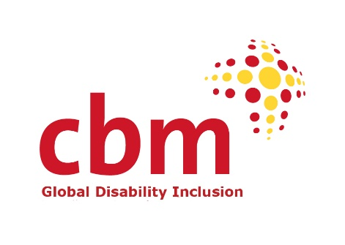

Employment Application Form

Please read the recruitment pack prior to completing this form as it holds further useful information. Use section 2 for your covering letter, you don’t need to include a separate one.

Once completed, please attach your CV with this application by the closing date and email to: recruitment@cbm-global.org

Post applied for: Nigeria Country Programme Manager
Where did you see the post advertised, or hear about it from?:
If you have a contact or referee in CBM Global, please let us know here:

1. Personal details
Title: Surname: First names:
Contact address:

Country:
Postcode:
Email address:

Home phone: | Mobile phone:
Please confirm that you have the right to work in one or more of the following countries.
Tick as many as applicable. If none are applicable we are unable to offer a work contract.
☐Ireland ☐Germany
☐UK ☐Belgium
UK

If you currently hold a work permit or visa, please give details including its type and expiry
date:
What is your current salary, and your salary expectations?:

#

If selected for interview, please indicate any dates you would be unable to attend due to prior immovable commitments:

2. What motivates you to apply for this job? A summary, like your covering letter.

3. Experience & Knowledge
Please look at the essential and desirable requirements in the Person Specification, and the main tasks of the role. In this section please detail your relevant skills, knowledge, experience and competencies that demonstrate that you are a suitable candidate for this role.
CBM welcomes applicants from diverse backgrounds and people with lived experience of disability.

4. Skills/Competencies/Personal Qualities

Please look at the essential and desirable requirements in the Person Specification, the main tasks of the Role, and list details of any Skills/Competencies/Personal Qualities you may consider to be relevant.

5. Qualifications, training and education

Please list details of any qualifications, training and education relevant to this position and the essential and desirable requirements.

6. Our Values

Take a look at our Values statement on page 2 of the recruitment pack. In brief, please share with us how you relate to these values and might contribute to them within this role.

7. References
Please give the name, address and telephone number of three referees (only one of which is personal) who can broadly represent your professional work and personal interests. This should include your current or most recent employer. This can also include voluntary posts.
1.Name of Referee and relationship to you:
Email: |  |  |  | Tel:
Can we contact this referee now? | Yes  No 
2. Name of Referee and relationship to you:
Email: |  |  | Tel:
Can we contact this referee now? | Yes  No 
3. Name of Referee and relationship to you:
Email: |  |  | Tel:
Can we contact this referee now? | Yes  No 

8. Declaration
The information on this form will be used for recruitment and selection purposes only and if your application is successful it will form part of your employment record. All unsuccessful applications will be destroyed twelve months after the closing date for positions advertised. If it is discovered that you have given any information, which you know to be false, or with hold any relevant information, your application may be rejected or any subsequent employment terminated.
I confirm that the information contained in this application form is correct.
Signature …………………………………………………………………….Date……..................................

Once completed and signed above, please attach your CV with this application by the closing date and email to: recruitment@cbm-global.org

CBM Global
Dr.-Werner-Freyberg-Str. 7, 69514 Laudenbach, Germany

CBM Global Disability Inclusion Vereniging - Dutch Chamber of Commerce No. 75787032
CBM Global Disability Inclusion GmbH - Amtsgericht Darmstadt HRB 100174
www.cbm-global.org

